Source https://www.viator.com/tours/Male/Snorkeling-Safari/d4673-9221P5
__________________________________________________________

Maldives Reef Explorer: Snorkeling Safari Adventure
__________________________________________________________
★★★★★ 4.7/5 20 reviews

Add to wishlist ♡

__________________________________________________________

3 hours | €110 per person

🏕  Image | 🏕  Image | 🏕  Image | 🏕  Image | 🏕  Image | 🏕  Image

__________________________________________________________
About This Tour
Dive into one of the world’s most spectacular marine environments on a guided snorkeling safari in the Maldives. This small-group ocean adventure takes you to three carefully selected reef locations, where vibrant coral gardens and tropical marine life create an unforgettable underwater experience. With expert guidance and safety support throughout, it’s ideal for both beginners and experienced snorkelers looking to explore pristine reef ecosystems.
__________________________________________________________
What’s Waiting for You
- Duration: 3 hours
- Group Size: Small group (max 8 travellers)
- Guide: Accredited snorkeling expert
- Languages: English
- Transport: Speedboat transfers between reefs
- Meeting Point: Lakudi Jetty, Hulhumalé Ferry Terminal, Malé
- Season: Year-round
__________________________________________________________

Check Dates & Availability

Select participants: (Age 99 and younger) - 1 +

Choose date:
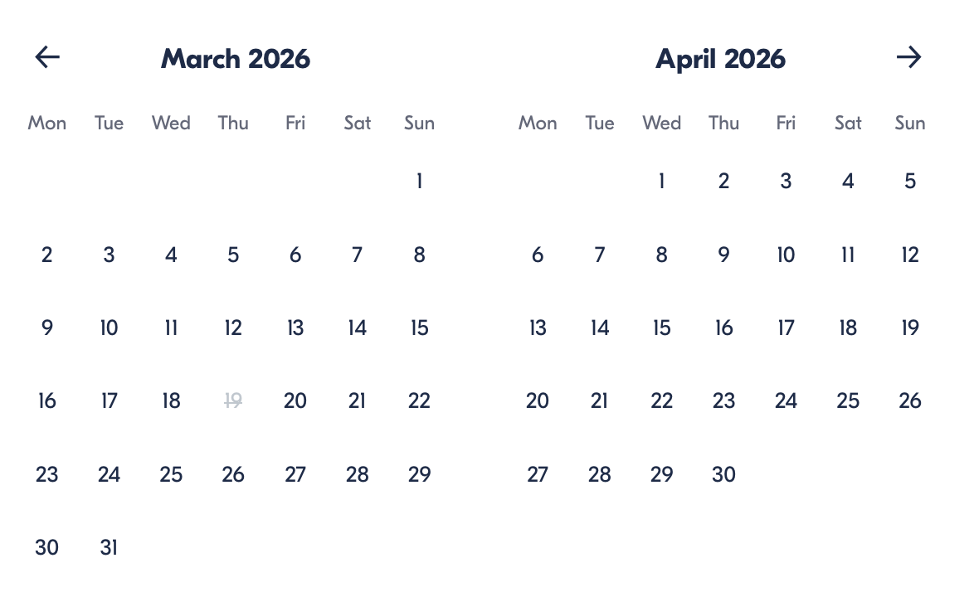

Check Availability

opens:

Participants: 1 March 16, 2026

Maldives Reef Explorer: Snorkeling Safari Adventure

- Start time: 9:30 AM

Cancellation:

- More than 24 hours before start — Full refund
- Less than 24 hours — No refund

Price breakdown: 1 Participant x €110

Total: €110

The total price includes all taxes and fees.

Add to cart Book now

__________________________________________________________
Tour Features
- Visit three unique snorkeling reefs in one trip
- Speedboat transfers between sites for maximum exploration time
- Swim among rays, reef sharks, turtles, and tropical fish
- Learn marine-life facts from an expert guide
- Small-group setting for safer, more personal experience
- Orientation on responsible reef interaction
__________________________________________________________
Detailed Itinerary

Departure & Welcome Briefing
Meet your captain and guide at Hulhumalé Jetty and receive a short safety and snorkeling briefing before boarding the speedboat.

Reef Stop 1 – Coral Gardens
Start your adventure exploring vibrant coral ecosystems teeming with colourful fish species and fascinating reef formations.

Reef Stop 2 – Marine Life Zone
At your second stop, keep watch for larger ocean creatures such as rays, reef sharks, and sea turtles while your guide shares insights into local marine biodiversity.

Reef Stop 3 – Hidden Reef
Discover a final carefully chosen site selected for ideal conditions, offering crystal-clear visibility and pristine underwater scenery.

Return Journey
Relax onboard as your crew transports you back to the jetty after your ocean exploration.
__________________________________________________________
Included in Price
- Certified snorkeling guide
- Mask, fins, and snorkel equipment
- Buoyancy aids
- Fish identification card
- Boat transport between sites
- Local taxes and fees
__________________________________________________________
Not Included
- Food or drinks
- Optional hotel pickup (available for an additional fee)
- Airport or resort transfers
- Gratuities
__________________________________________________________
Who Should Avoid This Tour
- Non-swimmers who cannot swim independently
- Travelers with mobility limitations
- Wheelchair users
- Guests staying on private island resorts (not eligible for departure logistics)
__________________________________________________________
Important Trip Info
- Swimming Ability: Participants must be able to swim unassisted.
- Group Size: Maximum 8 guests ensures safety and personal attention.
- Safety Standards: Tour follows Maldives Safe Tourism Guidelines and international hygiene protocols.
- Arrival Time: Please arrive early to allow check-in and equipment fitting.
- Weather: Tours may be rescheduled if sea conditions are unsafe.
__________________________________________________________

Cancellation Policy
- Cancel more than 24 hours before departure — full refund
- Cancel within 24 hours — no refund
__________________________________________________________
What Our Clients Are Saying

Overall rating  4.7/5  ★★★★★  Based on 20 reviews | Review summary  Guide 4.5/5  Transportation 4.6/5  Service 4.7/5  Organisation 4.5/5

Filter  - All traveller types  - Couples  - Group of friends  - Families  By star rating  - All star ratings  - 5 stars  - 4 stars  - 3 stars  - 2 stars  - 1 star | Search reviews (e.g., guide)  Sort by:  - Top picks  - Latest reviews  - Best ratings  - Lowest ratings
__________________________________________________________
★★★★★
David G. — Canada
Three incredible snorkeling spots and tons of marine life. Our guide made the experience both safe and educational.
★★★★☆
Maggie J. — UK
Beautiful reefs and colorful fish everywhere. Would have loved snacks on board, but the snorkeling itself was fantastic.
★★★★★
Elisa G. — UK
Swimming with rays and reef sharks was unforgettable. Small group size made it feel exclusive.
See more reviews
__________________________________________________________

Meta tags

Page - Maldives Reef Explorer: Snorkeling Safari Adventure

Title: Maldives Reef Explorer: Snorkeling Safari Adventure | Travellio Global

Description: Explore three stunning reef sites on a guided Maldives snorkeling safari. Swim with turtles, rays, and tropical fish with expert guides and small groups.

H1 - Maldives Reef Explorer: Snorkeling Safari Adventure
__________________________________________________________

